**Gateway Technical College**

DATABASES

152-050

Unit 6 Assignment

# Introduction

Please complete the document which will have you go back through the Create Statement from Chapter 7 of our book.  The video lecture will demonstrate examples of the syntax of the different clauses below which are in the attached assignment sheet.

**CREATE TABLE  
INSERT INTO  
UPDATE  
DELETE**

You will also practice SELECT statement to verify the above statements worked correctly

This lab describes 20 commands you need to create and execute on your local SQL Server.  Please make sure to paste the commands you create and execute and paste them into this word document.

MAKE SURE your commands work before you past them into the document.

Once completed, attach this completed word document to this assignment for grading.   Each command will be worth 5 points.

Use the **Discussion Forum** if you have any questions regarding the how to approach this assignment. You can also email your instructor directly for assistance if you have any questions.

Save your submission as ***lastnameFirstname_assign4.docx*** and submit it in the unit *Apply* section of the course.

# Instructions

You are to complete the following actions connected to your SQL Server. The syntax must work. For each question below – paste in print screens of your query window showing the command and the functioning output.

In order to do this lab, create a database called AdvancedDB with the following SQL statement:  
  
**CREATE DATABASE AdvancedDB**

Make sure you’re using the **AdvancedDB** you just created in order to complete the rest of the assignment.

1. Create a new table named **Student**. The table should have the following fields  
  
**YOUR COMMAND WAS:**

|  |
| --- |
| CREATE Table Student  (  StudentID Int Not Null Primary Key,  StudentLastName VarChar(25) Not Null,  StudentFirstName VarChar(20) Not Null,  StudentAddress VarChar(30),  StudentCity VarChar(15),  StudentState Char(2),  StudentZip VarChar(9),  StudentPhone VarChar(12),  StudentDOB Date Not Null  ) |

|  |  |  |  |
| --- | --- | --- | --- |
| **Column Name** | **Column Type and Length** | **Other Info** | **What column will contain – this is just for your information and understanding** |
| StudentID | Int | Not Null Primary Key | Unique Student ID |
| StudentLastName | Varchar 25 | Not Null | Student last name |
| StudentFirstName | Varchar 20 | Not Null | Student first name |
| StudentAddress | Varchar 30 |  | Student street address |
| StudentCity | Varchar 15 |  | City |
| StudentState | Char 2 |  | State |
| StudentZip | Varchar 9 |  | Zipcode |
| StudentPhone | Varchar 12 |  | Student phone number |
| StudentDOB | Date | NOT NULL | Student date of birth |

2. Create a new table named **Department**. The table should have the following fields

**YOUR COMMAND WAS:**

|  |
| --- |
| CREATE Table Department  (  DepartmentID Int Not Null Primary Key,  DepartmentName VarChar(30) Not Null  ) |

|  |  |  |  |
| --- | --- | --- | --- |
| **Column Name** | **Column Type and Length** | **Other Info** | **What column will contain – this is just for your information and understanding** |
| DepartmentID | Int | Not Null Primary Key | Unique department ID |
| DepartmentName | Varchar 30 | Not Null | Department name such as Information Technology |

3. Create a new table named **Instructor**. The table should have the following fields

**YOUR COMMAND WAS:**

|  |
| --- |
| CREATE Table Instructor  (  InstructorID Int Not Null Primary Key,  InstructorLastName VarChar(40) Not Null,  InstructorFirstName VarChar(20) Not Null,  InstructorPhone VarChar(12),  InstructorDepartmentID Int Not Null References Department(DepartmentID)  ) |

|  |  |  |  |
| --- | --- | --- | --- |
| **Column Name** | **Column Type and Length** | **Other Info** | **What column will contain – this is just for your information and understanding** |
| InstructorID | Int | Not Null Primary Key | Unique Instructor ID |
| InstructorLastName | Varchar 40 | Not Null | Instructor last name |
| InstructorFirstName | Varchar 20 | Not Null | Instructor first name |
| InstructorPhone | Varchar 12 |  | Student phone number |
| InstructorDepartmentID | Int | NOT NULL  References Department(DepartmentID) | Department number instructor teaches in |

4. Insert into the **Department** table the following rows:

**YOUR COMMAND WAS:**

|  |
| --- |
| INSERT INTO Department  VALUES  (1, 'BUSINESS INFORMATION TECH'),  (2, 'MARKETING'),  (3, 'ACCOUNTING'),  (4, 'ELECTRONICS'),  (5, 'INDUSTRIAL')  SELECT *  FROM Department |

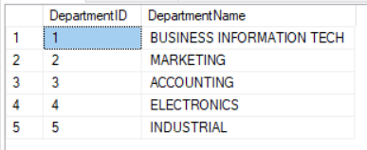

5. Insert into the **Instructor** table the following rows:

**YOUR COMMAND WAS:**

|  |
| --- |
| INSERT INTO Instructor  VALUES  (432, 'SMITH', 'BOB', '262-692-8999', 1),  (433, 'JONES', 'BETTY', '262-692-8799', 1),  (434, 'FAVRE', 'JANE', '262-692-7999', 2),  (442, 'GREEN', 'TOM', '262-692-8889', 2),  (532, 'EDWARDS', 'TONY', '262-692-4499', 3),  (742, 'BROWN', 'BUTCH', '262-692-5499', 4),  (772, 'CRASH', 'KATHY', '262-692-4479', 5),  (3432, 'WILLIAMS', 'SUE', '262-692-8759', 4) |

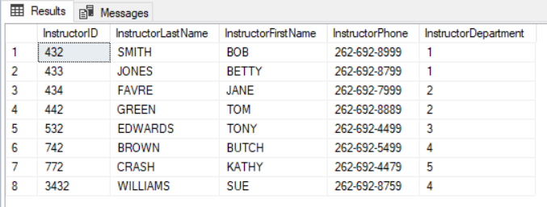

6. Insert into the student table the following rows:

**YOUR COMMAND WAS:**

|  |
| --- |
| INSERT INTO Student  VALUES  (123, 'JONES', 'TOM', '1400 SOUTH 27 ST', 'MILWAUKEE', 'WI', 53227, '414-645-8244', '1977-04-24'),  (124, 'MARSHELL', 'CHRIS', '9400 SOUTH 87 ST', 'MILWAUKEE', 'WI', 53229, '414-647-8544', '1981-01-24'),  (135, 'ADAMS', 'GEORGE', '3400 SOUTH 5 ST', 'MILWAUKEE', 'WI', 53227, '414-282-8644', '1965-11-20'),  (143, 'FLINSTONE', 'ALICE', '1840 SOUTH 57 ST', 'MILWAUKEE', 'WI', 53237, '414-645-8364', '1975-09-07'),  (153, 'BIDDELL', 'SAM', '2340 SOUTH 67 ST', 'MILWAUKEE', 'WI', 53227, '414-645-8244', '1979-12-14')  SELECT *  FROM Student |

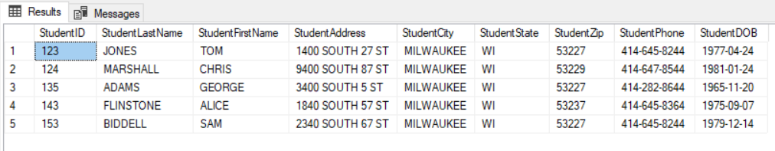

7. Display only the columns **Student ID**, **Student Last Name**, **Student First Name** and order them by student last name from the student table.

**YOUR COMMAND WAS:**

|  |
| --- |
| SELECT StudentID, StudentLastName, StudentFirstName  FROM Student  ORDER BY StudentLastName |

8. Display only the columns **Instructor ID**, **Instructor Last Name**, **Instructor First Name**, **Instructor Department ID** and order them by **Instructor Department ID** from the **Instructor** table

**YOUR COMMAND WAS:**

|  |
| --- |
| SELECT InstructorID, InstructorLastName, InstructorFirstName, InstructorDepartmentID  FROM Instructor  ORDER BY InstructorDepartmentID |

9. Display **Department ID**, **Department Name** and order them by department name from the **Department** table.

**YOUR COMMAND WAS:**

|  |
| --- |
| SELECT DepartmentID, DepartmentName  FROM Department  ORDER BY DepartmentName |

10. Modify the student record for student ID 123 to have a phone number of 414-888-1234.

**YOUR COMMAND WAS:**

|  |
| --- |
| UPDATE Student  SET StudentPhone = '414-888-1234'  WHERE StudentID = 123 |

11. Display only the student record for student ID 123 to verify the phone number change in the above statement.

**YOUR COMMAND WAS:**

|  |
| --- |
| SELECT *  FROM Student  WHERE StudentID = 123 |

12. Modify the student record(s) for student who have the zip code of **53227** to have a city name of **Cudahy**.

**YOUR COMMAND WAS:**

|  |
| --- |
| UPDATE Student  SET StudentCity = 'Cudahy'  WHERE StudentZip = 53227 |

13. Display only the student records for students who live in the city of **Cudahy**.

**YOUR COMMAND WAS:**

|  |
| --- |
| SELECT *  FROM Student  WHERE StudentCity = 'Cudahy' |

14. Modify the instructor record for instructor ID of **742** and change their department number to **2**, and verify with a select statement that the instructor record has changed.

**YOUR COMMAND WAS:**

|  |
| --- |
| UPDATE Instructor  SET InstructorDepartmentID = 2  WHERE InstructorID = 742 |

15. Display only the instructor records for instructors in departments 1, 3 or 5.

**YOUR COMMAND WAS:**

|  |
| --- |
| SELECT *  FROM Instructor  WHERE InstructorDepartmentID = 1 or InstructorDepartmentID = 3 or InstructorDepartmentID = 5 |

16. Delete the student record for student ID 135 and very with a select statement that the student record was deleted.

**YOUR COMMAND WAS:**

|  |
| --- |
| DELETE FROM Student  WHERE StudentID = 135 |

17. Delete the record for department ID 4 from the Department table. Was it successful? If not, why?

**YOUR COMMAND AND EXPLANATION:**

|  |
| --- |
| DELETE FROM Department  WHERE DepartmentID = 4  No since theres no DepartmentID = 4 |

18. Delete the record for instructor ID 3432 from the instructor table. Was it successful? If not, why?

**YOUR COMMAND AND EXPLANATION:**

|  |
| --- |
| DELETE FROM Instructor  WHERE InstructorID = 3432  yes |

19. What can be said about the Department table and instructor table? Which one is the parent table and which one is the child table (Where is the references clause when you created the table? Which one needs to have rows first?)?

**YOUR EXPLANATION:**

|  |
| --- |
| Department Table is the parent function |

20. Run the following statement. What happens and why? Is it a syntax or logic error?

DELETE Student  
WHERE 1=1;

**YOUR EXPLANATION:**

|  |
| --- |
| Everything is deleted as it did not specify what to delete |